Aspect Oriented Programming Overview

- Most of the Enterprise Applications have some common crosscutting concerns that are applicable for different types of Objects and Modules. Some of the common crosscutting concerns are logging, transaction, caching, security etc.
- In Object Oriented Programming, modularity of application is achieved by Classes whereas in Aspect Oriented Programming, modularity of application is achieved by Aspects and they are configured to cut across different classes.
- AOP is a new programming paradigm. It is like Triggers in SQL. In SQL, a trigger is created for a specific action such as insert, update or delete on a table or a view. This trigger then executes at a chosen scenario.
- AOP is similar to triggers, here an Aspect is created, which executes on a chosen scenario such as before, after, around and so on.

AOP Terminology

Aspect

- An Aspect is a class that implements an enterprise application concerns that cut across multiple classes.
- An Aspect is a normal class configured through Spring XML configuration or we can use Spring AspectJ integration.

Join Point
- A Join Point is a specific point in the application such as method execution, exception handling, changing object variable values etc.
- Spring supports only method execution Join Point.

Advice

- Advice represents an action taken by an Aspect at a particular Join Point. There are different types of Advices:
Advice | Description
Before | This advice runs before the execution of join point method.
After (finally) | This advice runs after the execution of join point method either the join point method finishes execution normally or throws an exception.
After Returning | This advice runs after the execution of join point method finishes execution normally.
After Throwing | This advice runs if join point method throws exception.
Around | This advice runs before and after the execution of join point method.

Pointcut

- Pointcut is an expression language of AOP that matches Join Points. Spring framework uses the AspectJ Pointcut expression language.

Target Object

- It is the object that is being advised by one or more Aspects. It is also known as proxied object in Spring framework because Spring AOP is implemented using runtime proxies.

AOP Proxy

- AOP Proxy is an object created by the AOP framework in order to implement the aspect contracts that is advise method executions and so on.
- In the Spring Framework, an AOP proxy is a a JDK dynamic proxy or a CGLIB proxy.

Weaving

- Weaving is a process of linking aspects with other objects to create advised proxy objects.
- Weaving can be done at compile time, load time or runtime. Spring AOP performs weaving at the runtime.
AOP Implementations

- AOP implementations are provided by:

- AspectJ
- Spring AOP
- JBoss AOP

Aspect Oriented Programming with Spring

- Spring framework supports the following kinds of AOP:

- AspectJ Annotation-Driven AOP (mostly used)
- AspectJ XML-Driven AOP
- Classic Spring Proxy-Based AOP

AspectJ Annotation-Driven AOP

AspectJ Annotations

@Aspect
- The @Aspect annotation is used to declare a class as Aspect. The @Aspect annotation is used at class level.
- The annotations used to create advices are given below:
Annotation | Description
@Before | Declares before advice. It is applied before calling the actual method.
@After | Declares after advice. It is applied after calling the actual method irrespective of method execution.
@AfterReturning | Declares after returning advice. It is applied after calling the actual method execution completes successfully.
@Around | Declares around advice. It is applied before and after calling the actual method.
@AfterThrowing | Declares throws advice. It is applied if actual method throws exception.

AspectJ Libraries

- In order to use AspectJ Annotation-Driven Aspects in a Spring project, the following jar files are required in addition to standard Spring jar files:
- aspectjrt.jar
- aspectweaver.jar
- aopalliance-1.0.jar

Enabling AspectJ <aop:aspect-autoproxy>

- The <aop:aspectj-autoproxy/> element enables Spring AspectJ support with auto proxy at runtime.
- To use <aop:aspect-autoproxy/>, include the aop namespace in the Spring XML file.

Pointcut Expressions

execution

- This is mostly used designator. It is used for matching method execution join points. The format of an execution expression is:
execution (modifiers-pattern? ret-type-pattern declaring-type-pattern?
name-pattern (param-pattern) throws-pattern?)
- All parts except the returning type pattern (ret-type-pattern in the snippet above), name pattern, and parameters pattern are optional.
- Some examples of common pointcut expressions are given below:
Example | Description
execution(public * *(..)) | The execution of any public method
execution(* set*(..)) | The execution of any method with a name beginning with "set"
execution(* com.xyz.service.AccountService.*(..)) | The execution of any method defined by the AccountService interface
execution(* com.xyz.service..(..)) | The execution of any method defined in the service package
execution(* com.xyz.service...(..)) | The execution of any method defined in the service package or a sub-package

within

- Limits matching to join points within certain types (simply the execution of a method declared within a matching type).
Example | Description
within(com.xyz.service.*) | Any join point within the service package
within(com.xyz.service..*) | Any join point within the service package or a sub-package

Combining pointcut expressions
- The Pointcut expressions can be combined using below operators:
- && - Operator is used to combine execution() and within() designators
- || - Operator can be used to indicate or relationship
- ! - Operator can be used to negate the effect of a designator
- For example, the following expression confirms the reach of the pointcut to only the com.pack package:
execution(* Product.multiply(..)) && within (com.pack)
- This shows that execution is used as the primary designator and within is used to constrain the Pointcut’s reach.

@Pointcut
- The @Pointcut annotation is used to define the pointcut. We can refer the pointcut expression by name also.
- Let's see a simple example of Pointcut expression.
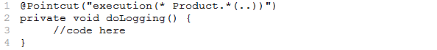
- The name of the Pointcut expression is doLogging(). It will be applied on all the methods of Product interface regardless of return type.
Custom Advice Annotations
- Create a custom annotation for logging as shown below:
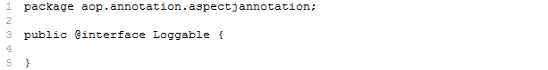
- Use @annotation pointcut expression to define before advice by using @Loggable annotation
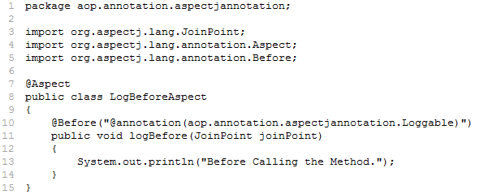
- Use the custom annotation (@Loggable) as shown below:
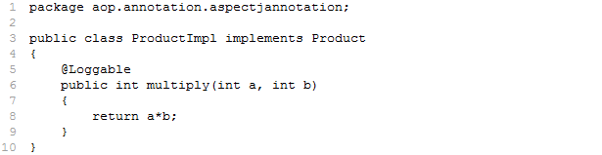
Example to demonstrate AspectJ Annotation-Driven AOP
Solution [Product.java]
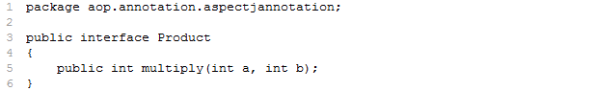

Explanation:
- The Product interface contains multiply() method which accepts two arguments of type int.

Solution [ProductImpl.java]
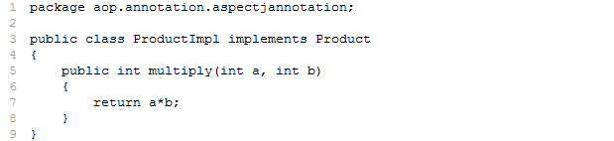

Explanation:
- The ProductImpl is an implementation class of Product interface. It returns the product of the two numbers given as arguments.

Solution [LogBeforeAspect.java]
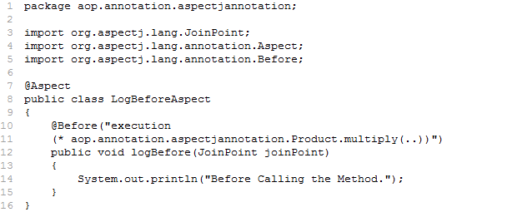
Explanation:
- The @Aspect annotation declares the LogBeforeAspect class as an Aspect.
- The @Before annotation declares the logBefore() method as Before advice.
- The @Before annotation uses an in-place Pointcut expression to indicate when this advice executes.
@Before("execution(* aop.annotation.aspectjannotation.Product.multiply(..))")
- This Pointcut expression indicates that logBefore() method will be executed before the execution of multiply() method of Product interface.

Solution [LogAfterAspect.java]
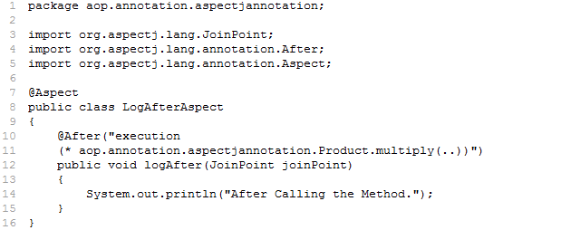

Explanation:
- The @Aspect annotation declares the LogAfterAspect class as an Aspect.
- The @After annotation declares the logAfter() method as After advice.
- The @After annotation uses an in-place Pointcut expression to indicate when this advice executes.
@After("execution(* aop.annotation.aspectjannotation.Product.multiply(..))")
- This Pointcut expression indicates that logAfter() method will be executed after the execution of multiply() method of Product interface.

Solution [LogAfterReturningAspect.java]
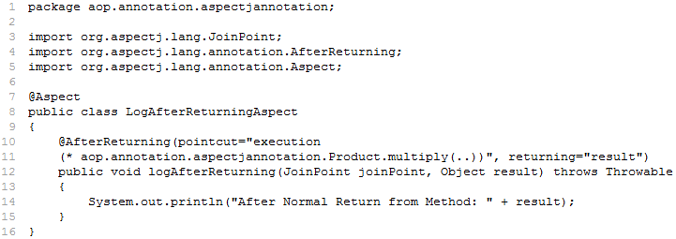

Explanation:
- The @Aspect annotation declares the LogAfterReturningAspect class as an Aspect.
- The @AfterReturning annotation declares the logAfterReturning() method as AfterReturning advice.
- The @AfterReturning annotation uses an in-place Pointcut expression to indicate when this advice executes.
@AfterReturning(pointcut="execution(*
aop.annotation.aspectjannotation.Product.multiply(..))", returning="result")
- This Pointcut expression indicates that afterReturning() method will be executed after the successful execution of multiply() method of Product interface.

Solution [LogAfterThrowsAspect.java]
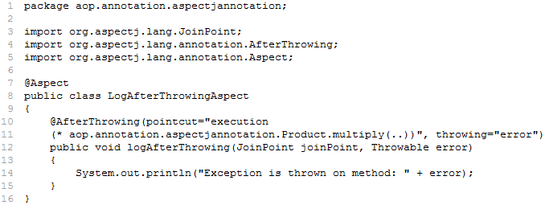

Explanation:
- The @Aspect annotation declares the LogAfterThrowingAspect class as an Aspect.
- The @AfterThrowing annotation declares the logAfterThrowing() method as AfterThrowing advice.
- The @AfterThrowing annotation uses an in-place Pointcut expression to indicate when this advice executes.
@AfterThrowing(pointcut="execution(*
aop.annotation.aspectjannotation.Product.multiply(..))", throwing="error")
- This Pointcut expression indicates that logAfterThrowing() method will be executed, only if the multiply() method of Product interface throws an exception.

Solution [LogAroundAspect.java]
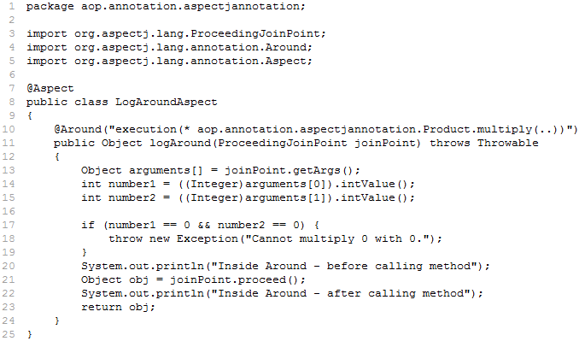

Explanation:
- The @Aspect annotation declares the LogAroundAspect class as an Aspect.
- The @Around annotation declares the logAround() method as Around advice.
- The @Around annotation uses an in-place Pointcut expression to indicate when this advice executes.
@Around("execution(* aop.annotation.aspectjannotation.Product.multiply(..))")
- This Pointcut expression indicates that logAround() method will be executed before and after the multiply() method of Product interface.

Solution [context.xml]
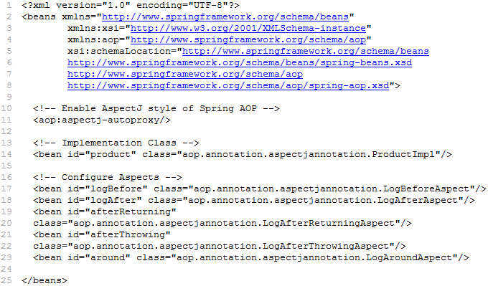

Explanation:
- The <aop:aspectj-autoproxy> element enables AspectJ in Spring application.
- To use <aop:aspect-autoproxy>, include the “aop” namespace in the Spring XML configuration file.
Solution [ProductTest.java]
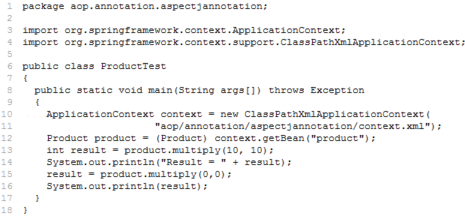

Jars required for executing above example:

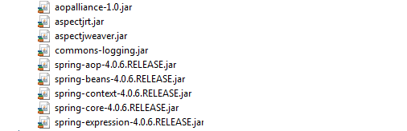
AspectJ XML-Driven Aspects

- Spring supports XML based AspectJ. Following are the XML elements that are used to define advices:
XML Elements | Description
<aop:before> | This is applied before calling the actual business logic method
<aop:after> | This is applied after calling the actual business logic method
<aop:after-returning> | This is applied after calling the actual business logic method executes successfully
<aop:after-throwing> | This is applied if actual business logic method throws exception
<aop:around> | This is applied before and after calling the actual business logic method

Configuring Aspects and Advisors

- All aspect and advisor elements must be placed within <aop:config> elements. The <aop:config> element can contain Pointcut, Advisor and Aspect elements.
<aop:config>
<!-- Aspects and Advisors -->
</aop:config>

Declaring an Aspect

- An Aspect is a Java class defined as a bean in the Spring XML configuration file.
- An Aspect is declared using <aop:aspect> and the backing bean is referenced using the ref attribute.
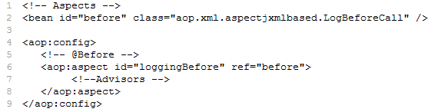

Declaring Advisors

Before Advice

- The Before Advice runs before a matching method is executed. It is declared inside <aop:aspect> using <aop:before> element as shown below:
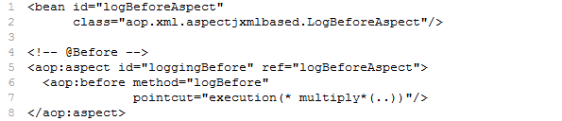

- The “method” attribute takes name of the method as value (i.e., logBefore). This method must be defined in the Aspect class.
- The “pointcut” attribute takes an in line Pointcut expression.
- We can also use pointcut-ref attribute as shown below:
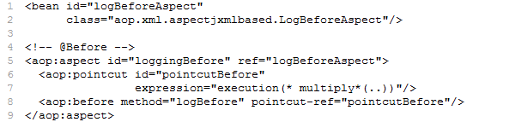

After Advice

- The After Advice runs after a matching method execution finishes normally or exceptionally. It is declared inside <aop:aspect> using <aop:after> element as shown below:
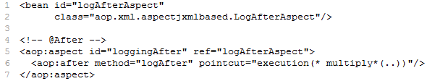

After-Returning Advice

- The After-Returning Advice runs after a matching method execution finishes normally. It is declared inside <aop:aspect> using <aop:after-returning> element as shown below:
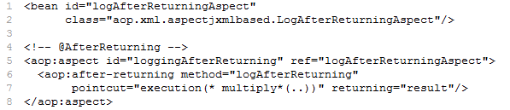

- The logAfterReturning() method must declare a parameter named result. The method signature may be declared as:
public void logAfterReturning(JoinPoint joinPoint, Object result) throws Throwable

After-Throwing Advice

- The After-Throwing Advice runs if a matching method throws an exception. It is declared inside <aop:aspect> using <aop:after-throwing> element as shown below:
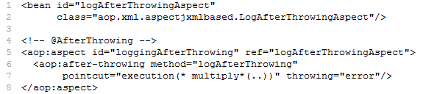
- The logAfterThrowing() method must declare a parameter named error. The method signature may be declared as:
public void logAfterThrowing(JoinPoint joinPoint, Throwable error)

Around Advice

- The Around Advice runs before and after the matching method execution. It is declared inside <aop:aspect> using <aop:around> element as shown below:
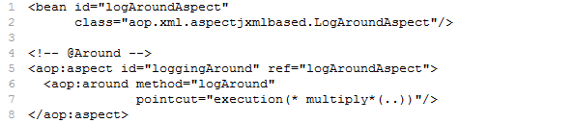

Enabling AspectJ <aop:aspect-autoproxy>

- The <aop:aspectj-autoproxy/> element enables Spring AspectJ support with auto proxy at runtime.
- To use <aop:aspect-autoproxy/>, include the aop namespace in the Spring XML file.

AspectJ Libraries

- In order to use AspectJ XML-Driven Aspects in a Spring project, the following jar files are required in addition to the standard Spring jar files.
- aspectjrt.jar
- aspectweaver.jar
- aopalliance-1.0.jar

Example to demonstrate AspectJ XML-Driven Aspects

Solution [Product.java]
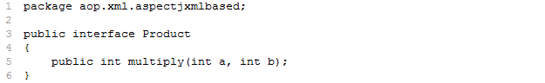

Solution [ProductImpl.java]
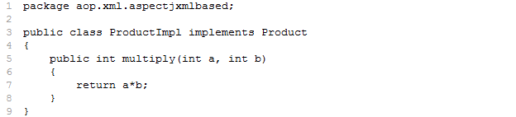

Solution [LogBeforeAspect.java]
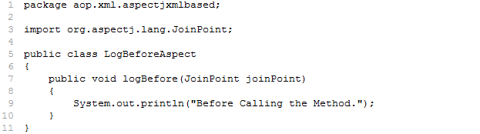

Solution [LogAfterAspect.java]
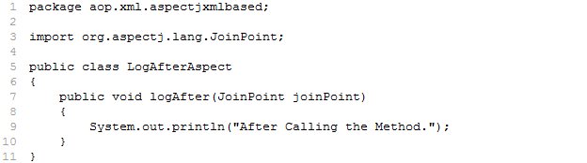

Solution [LogAfterReturningAspect.java]
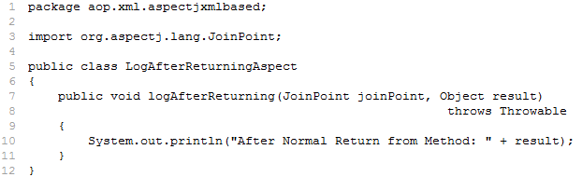

Solution [LogAfterThrowingAspect.java]
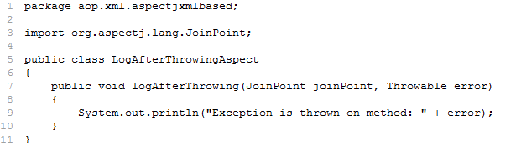

Solution [LogAroundAspect.java]
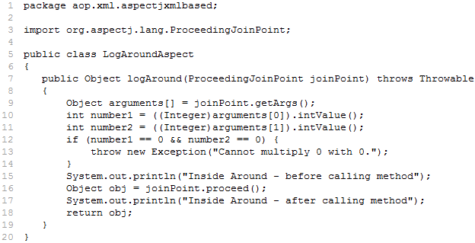

Solution [context.xml]
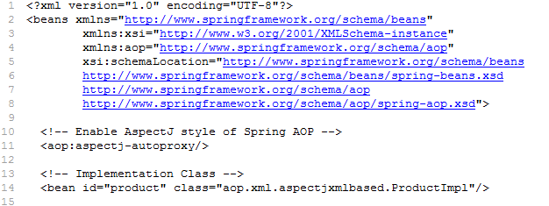
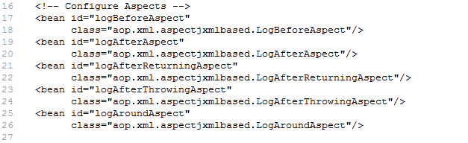
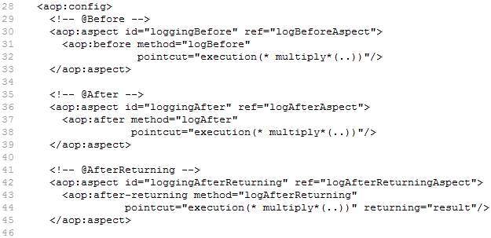

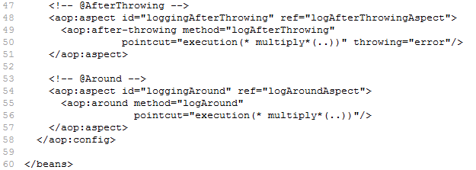

Solution [ProductTest.java]
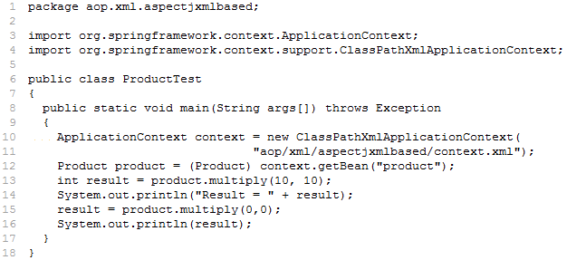

Jars required for executing above example:

